# Final Assignment 1

You are working on a project to develop Student Management application. This application is to help students to improve their self-knowledge and skills. It would include the following capabilities:

* Allow students to register for university-sponsored courses, such as C++ programming, Machine Learning, Data Mining, Project Management, and Database Design, etc.
* Allow students to register for university-sponsored classes and courses to help them manage their learning progresses, improve their soft skill such as public speaking, communication, marketing.
* Track data of student involvement in these courses.
* Offer incentives for students to join the courses and do well in them (e.g., incentives for achieving score goals, winning team competitions, etc.)

## Request 1 - Work Breakdown Structure

Develop a WBS for the project. Break down the work to Level 3 or Level 4, as appropriate.

Assume that the Level 1 category is called Software Project, and that the Level 2 categories are Initiating, Planning, Executing, Monitoring and Controlling, and Closing. Under the Executing section, include Level 3 categories of Analysis, Design, Prototyping, Testing, Implementation, and Support. The Support category includes Level 4 items for Training, Documentation, User Support, and Enhancements

1. Software Project
2. Initiating
   1. Prepare project charter
      1. Meet with project sponsor
      2. Complete project charter
3. Planning
   1. Make WBS
   2. Estimate cost and effort
   3. Create project schedule
   4. HR
4. Executing
   1. Analysis
      1. Prepare user requirements
         1. Have interviews with stakeholders
         2. Write and continually update user requirements
   2. Design
      1. Prepare software design document
         1. Prepare architecture design
         2. Prepare general design: 3 modules
            1. Course registering: may need different designs for different class types – academic or soft skill
            2. Student involvement tracking
            3. Study incentives (game or bonus marks for study)
         3. Prepare detailed design: 3 modules
         4. Meet with stakeholders
         5. Prepare detailed design
   3. Prototyping
      1. Code for course registering module
      2. Code for student involvement tracking module
      3. Code for study incentives module
   4. Testing
      1. Unit test for each function in each module (do this simultaneously with coding) against detailed design
      2. Write and execute integration test for each module against architecture design
      3. Write and execute system test against system design
      4. Send finished products to users for acceptance testing against business requirements
   5. Implementation
      1. Deploy project for beta-testing
   6. Support
      1. Training
         1. Tech lead gives training to team developers (following conventions and best practices as well as technical knowledge about the technology used)
         2. Test lead gives training to testers and makes clear about standards and form following conventions
      2. Documentation
         1. Update documentation for maintenance
         2. Prepare software manual
      3. User Support
         1. Prepare a FAQ list
         2. Assign someone as a helpdesk to answer user’s questions
      4. Enhancements
         1. Add features if required
5. Monitoring and Controlling
   1. Project management
   2. Configuration management: make sure product’s functional and non-functional attributes are consistent with project’s requirements and design document.
   3. Contract management
   4. Risk prevention
      1. Prepare a risk log
6. Closing
   1. Have meeting with stakeholders to inform about the completion of projects, as well as experience and lessons learned, resolve any issues if exists.
   2. Release to users

## Request 2 - Deliverables

Identify at least five milestones mapped to the main deliverables for the project. For each milestone, write short describing using SMART criteria.

|  |  |
| --- | --- |
| **Milestones** | **Description** |
| Project start | After all planning jobs are done and project charter deliverables are agreed upon, the project officially kicks off and project team start working based on given project schedule. |
| Complete software requirements | Within 2 weeks from project start, project manager will gather and update all necessary requirements |
| Complete detailed design requirements | Within 2 weeks, tech lead and developer will complete general and detailed designs requirements for all modules |
| Acquire and configure hardware/ software | Within 1-2 days tech lead will finish configuring all hardware/software and developing environment ready for project development |
| Complete source coding and testing and user manual | Within 1 month, while tech lead and developer works on coding for each function of the module based on detailed design, they will write and execute unit test after finishing each function/module also. Two testers will write and test cases simultaneously (based on detailed design also) for integration and system test. |
| Deploy solution | Tech lead or project manager will deploy solution on server for testing and checking all functional and non-functional attributes daily |
| Release for use | Within one day after project completion, teach lead will deploy project on main server ready for use |

## Request 3 – Project Scheduling

Assume that you have defined and estimate project schedule with below high level activities

|  |  |  |
| --- | --- | --- |
| **Activity** | **Preceding Activity** | **Duration in Weeks** |
| Start | None | 0 |
| A | Start | 5 |
| B | Start | 10 |
| C | B | 11 |
| D | A | 20 |
| E | D, B | 7 |
| F | C | 8 |
| G | E, F | 3 |
| H | G | 6 |
| End | F, H | 0 |

Draw AON (activity on node) (or PDM) network diagram and identify the project duration

*The precedence diagram method (****PDM****)*

**Example:**

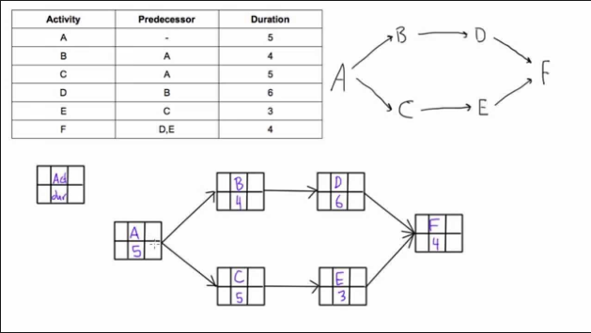

## Request 4 – Schedule Updating & Tracking

After 4 weeks, your manager/sponsor ask you to speed up so that your project would finish 2 weeks sooner, please define at least three solutions ordered by the choosing priority and included relevant explanation.

* Add overtime work
* Hire more people
* Readjust priority: Defer less important features or quality attributes such as optimization or UI to later releases
* Build a pro core team: get good members from other teams
* Compromise quality
* Outsource

## Request 5 – Cost Evaluation

Your project is scheduled for 2 years. There are six different teams working on five major functional areas. Some teams are ahead of schedule while others are falling behind. There are cost overruns in some areas but you’ve also saved costs in others. Due to all this, it is difficult to understand whether you are over or under budget. Nine months into the project, while the total project budget is $4,200,000, you’ve already spent $1,650,000. CPI is 0.875. Can you perform EV analysis and forecast

EAC = BAC / CPI  
= 4,200,000 / 0.875 = 4,800,000

ETC = EAC – AC  
= 4,800,000 – 1,650,000 = 3,150,000

VAC = BAC – EAC  
= 4,200,000 – 4,800,000 = -600,000

As Variance at completion is negative, the project will be over budget at completion by $600,000.

Since the Variance At Completion is negative, the project will be over budget at completion by $600,000

Estimate at completion (**EAC**) = Budget at completion (**BAC**) / Cost performance index (**CPI**)

ETC = EAC – AC (estimate to complete = estimate at completion – actual cost)

VAC = BAC – EAC

* Nếu VAC > 0 => Project is under budget
* Nếu VAC < 0 => Project is over budget

<https://www.pmclounge.com/2019/03/sample-pmp-questions-of-earned-value-management-with-answers/>